**Lab 7:**

**Characterization and DC Biasing of the BJT**

Name: Wan-Yu Liao

ECEN 325 Section 514

TA: Mandela

Lab Date: October 18, 2019

Lab Report Due Date: October 22, 2019

**Calculations**

**(1)**

**NPN Resistive DC Biasing Circuit**

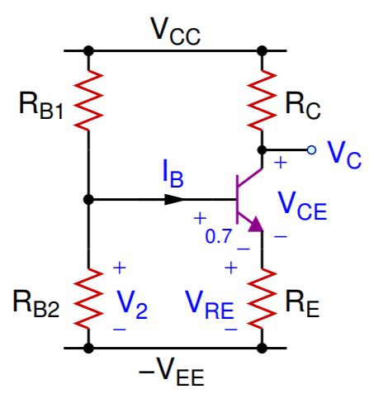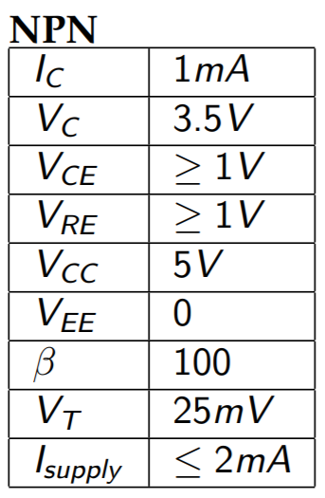



**PNP Resistive DC Biasing Circuit**

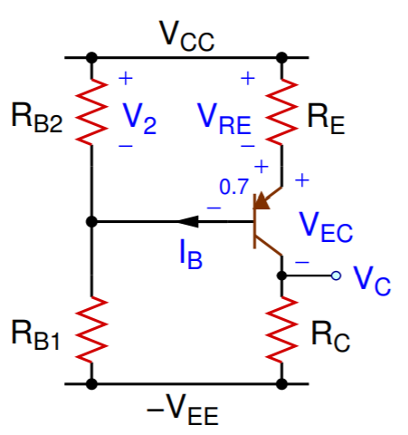 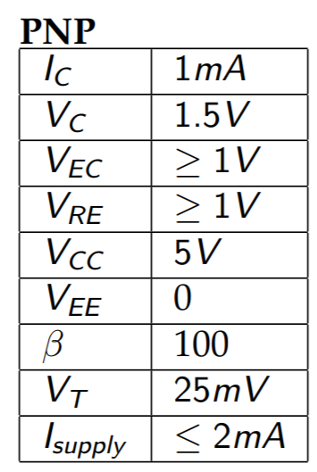



**(2)**

**NPN DC Biasing Circuit**

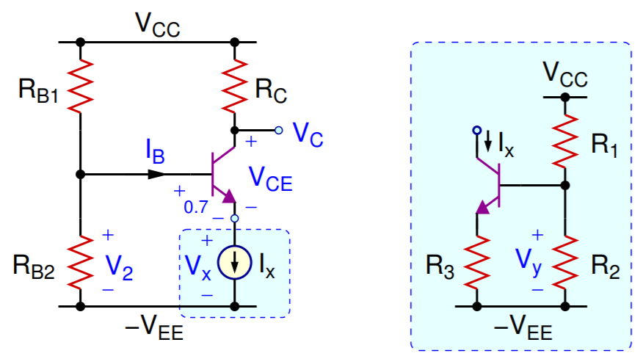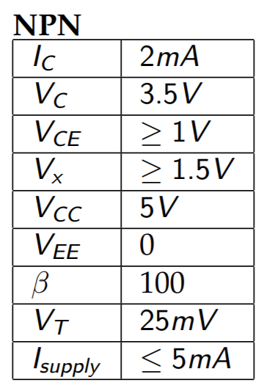



**PNP DC Biasing Circuit**

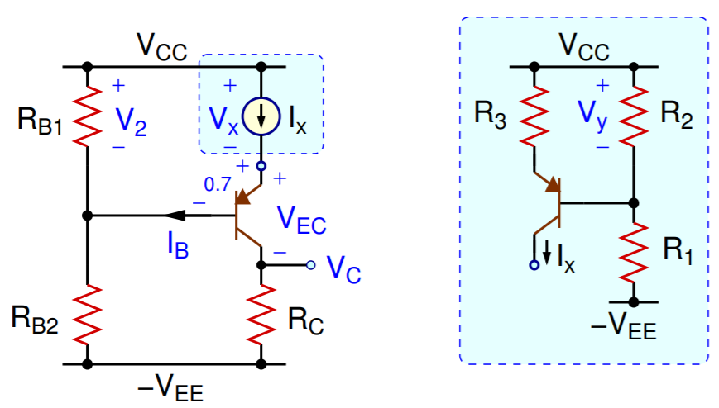 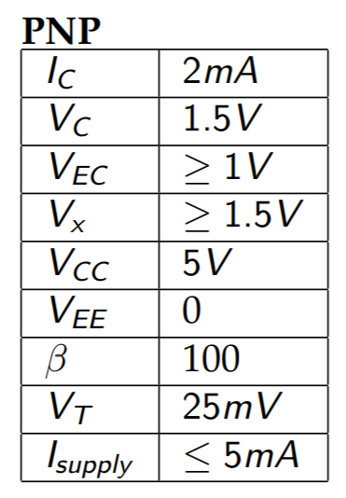



**Simulations**

**(1)**

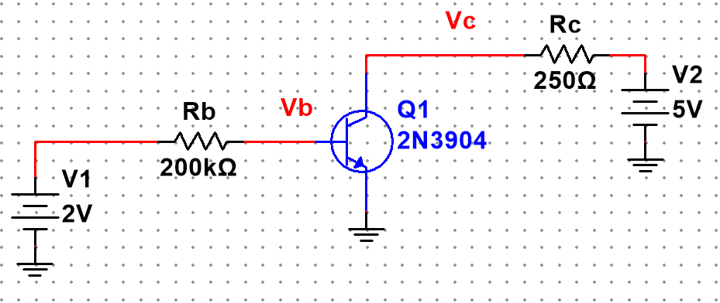

Figure 1: Schematic of NPN BJT characterization circuit for Fig. 2 ▲

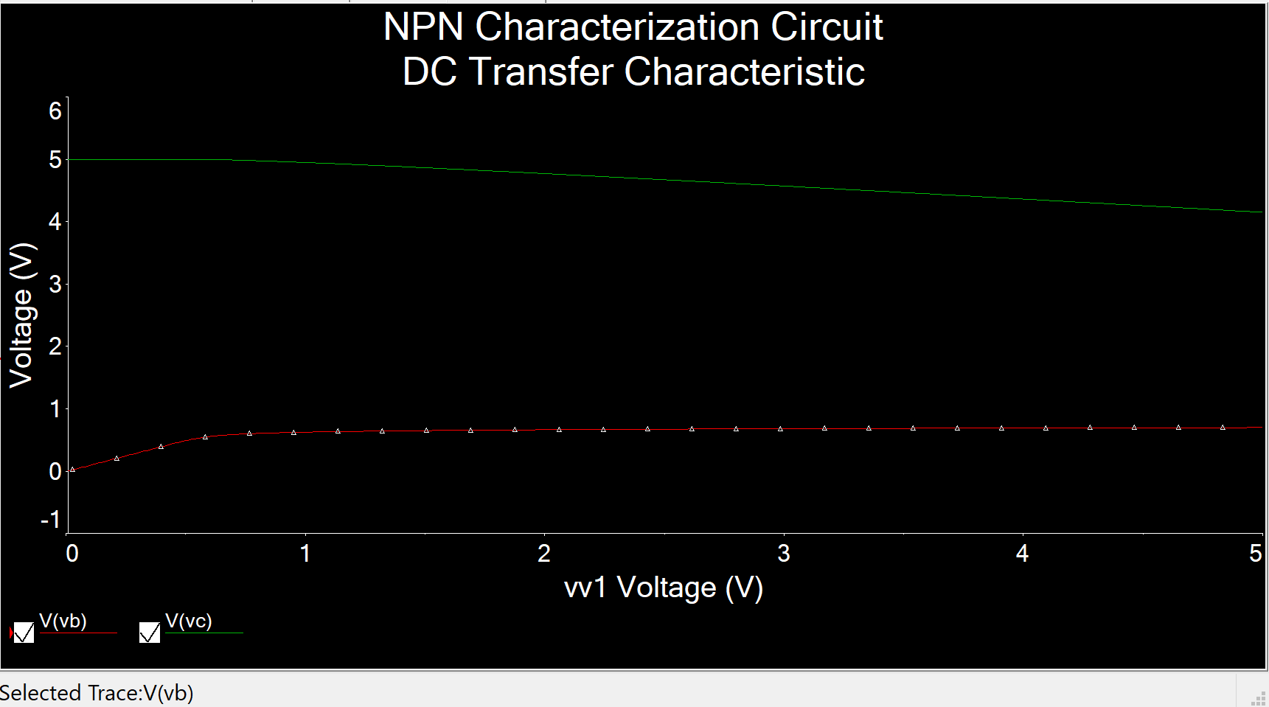

Figure 2: Simulation plot of NPN BJT characterization circuit using DC sweep of V1 from 0 to 5V, while V2 = 5V ▲

Figure 3: Excel plot for collector current (IC) of an NPN BJT as a function of Vbe ▲

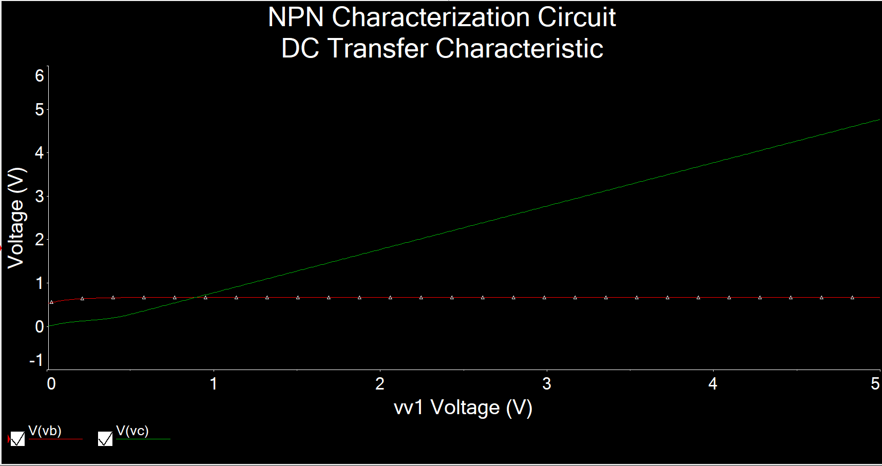

Figure 4: Simulation plot of NPN BJT characterization circuit using DC sweep of V2 from 0 to 5V, while V1 = 2V ▲

Figure 5: Excel plot for collector current (IC) of an NPN BJT as a function of Vce ▲

**(2)**

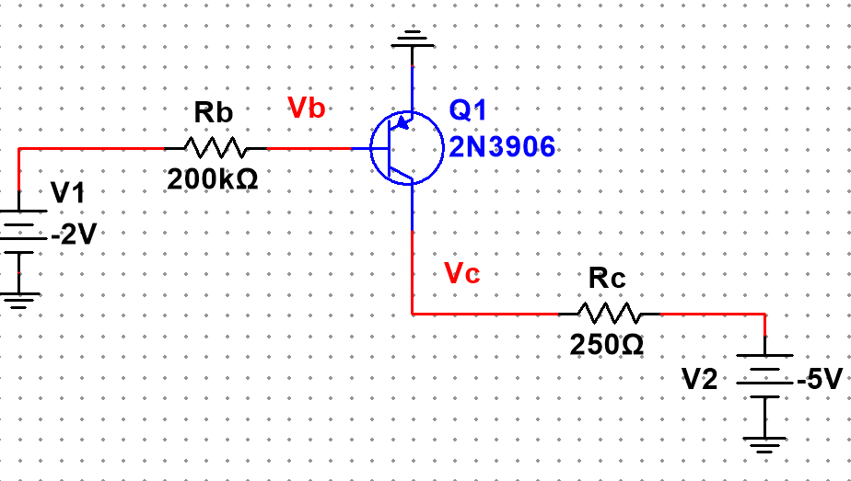

Figure 6: Schematic of NPN BJT characterization circuit for Fig. 4 ▲

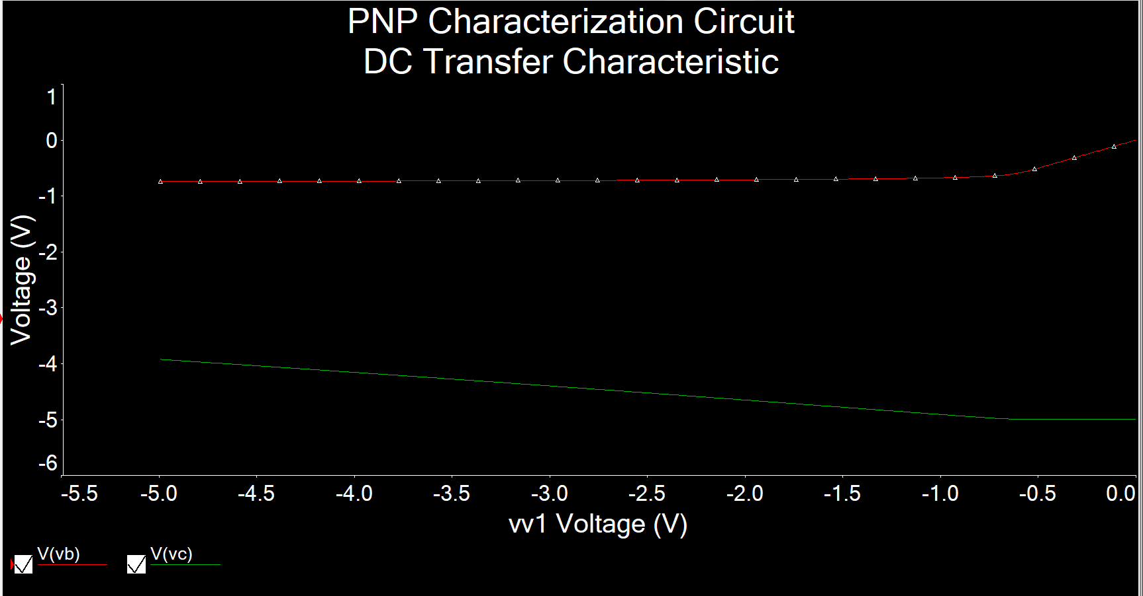

Figure 7: Simulation plot of PNP BJT characterization circuit using DC sweep of V1 from -5 to 0V, while V2 = -5V ▲

Figure 8: Excel plot for collector current (IC) of an PNP BJT as a function of Veb ▲

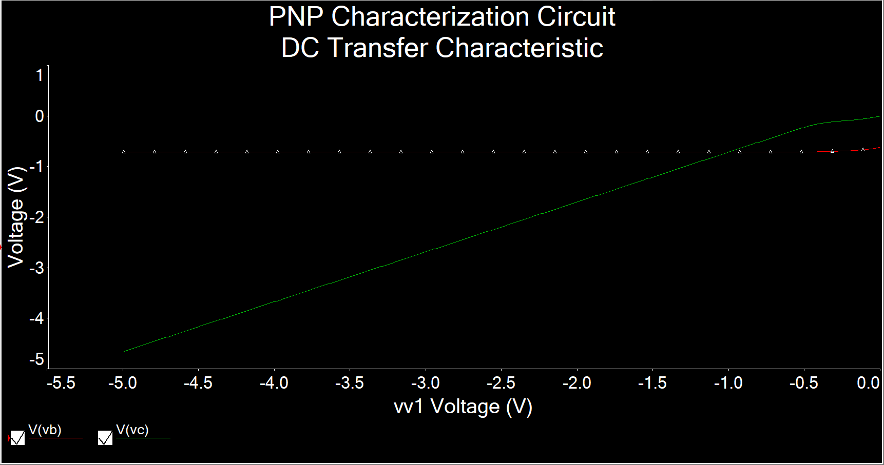

Figure 9: Simulation plot of PNP BJT characterization circuit using DC sweep of V2 from -5 to 0V, while V1 = -2V ▲

Figure 10: Excel plot for collector current (IC) of an PNP BJT as a function of Vec ▲

**(3)**

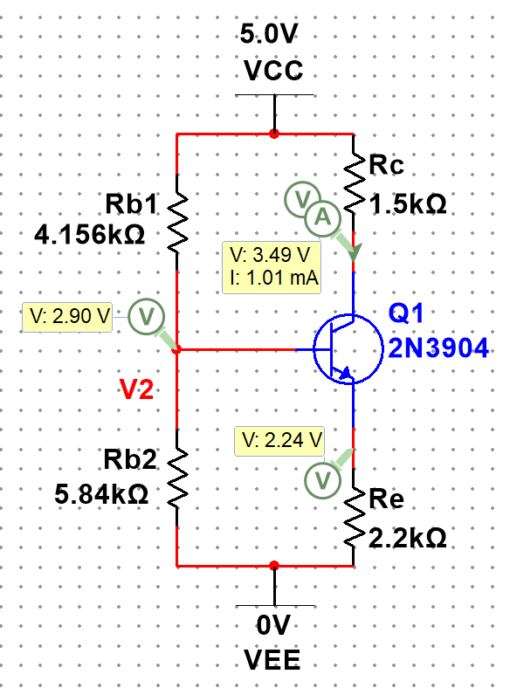

Figure 11: Schematic and interactive simulation for IC, VC, VRE, and V2 for NPN Resistive DC biasing circuit in Fig. 6(a) ▲

IC = 1.01mA, VC = 3.49V, VRE = 2.24V, V2 = 2.90V

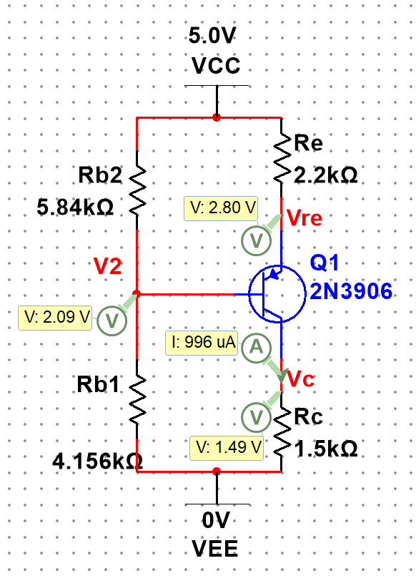

Figure 12: Schematic and interactive simulation for IC, VC, VRE, and V2 for PNP Resistive DC biasing circuit in Fig. 6(b) ▲

IC = 0.996mA, VC = 1.49 V, VRE = 5 - 2.8 = 2.2V, V2 = 5 – 2.09 = 2.91V

**(4)**

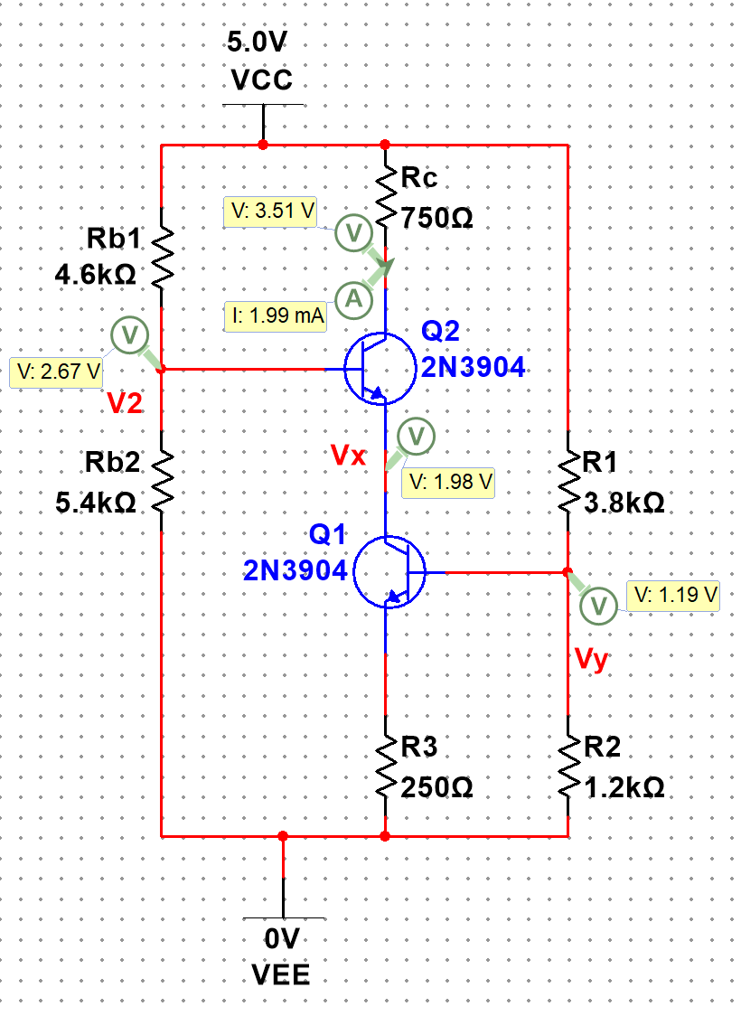

Figure 13: Schematic and interactive simulation for IC, VC, V2, Vx, and Vy for NPN DC biasing circuit using current source in Fig. 7(a) and Fig. 7(b) ▲

IC = 1.99mA, VC = 3.51V, V2 = 2.67V, Vx = 1.98V, Vy = 1.19V

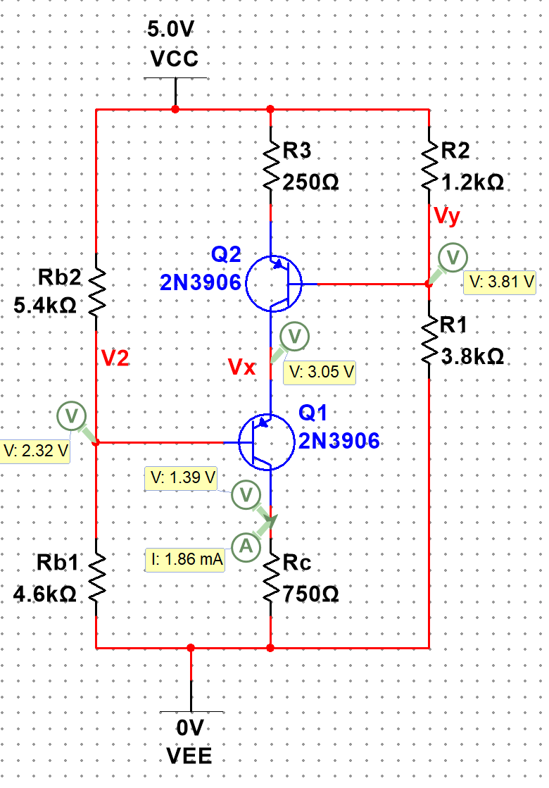

Figure 14: Schematic and interactive simulation for IC, VC, V2, Vx, and Vy for NPN DC biasing circuit using current source in Fig. 8(a) and Fig. 8(b) ▲

IC = 1.86mA, VC = 1.39V, V2 = 5 – 2.32 = 2.68V, Vx = 5 – 3.05 = 1.95V, Vy = 5 – 3.81 = 1.19V

**Measurements**

**(1)**

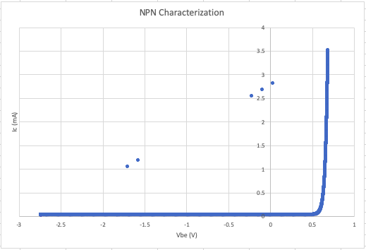

Figure 11: Excel plot for collector current (IC) of an NPN BJT as a function of Vbe ▲

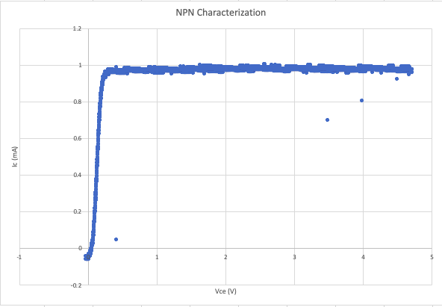

Figure 12: Excel plot for collector current (IC) of an NPN BJT as a function of Vce ▲

**(2)**

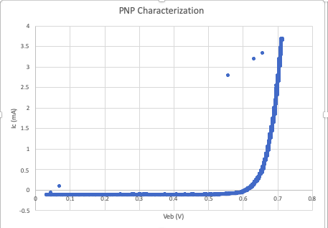

Figure 13: Excel plot for collector current (IC) of an PNP BJT as a function of Veb ▲

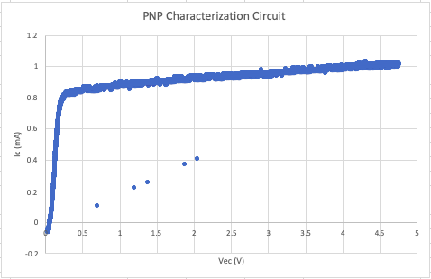

Figure 14: Excel plot for collector current (IC) of an PNP BJT as a function of Vec ▲

**(3)**

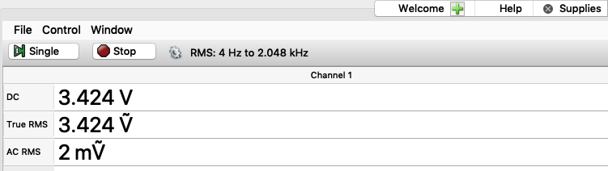

Figure 15: VC for NPN Resistive DC biasing ▲

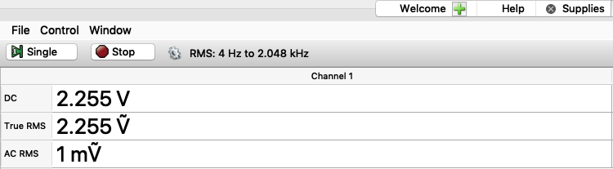

Figure 16: VRE for NPN Resistive DC biasing ▲

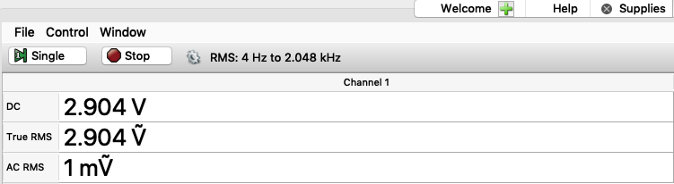

Figure 17: V2 for NPN Resistive DC biasing ▲

Ic = (5-3.424)/1500 = 1.05mA

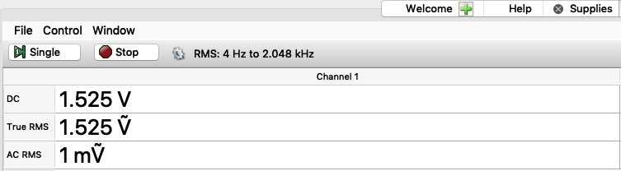

Figure 18: VC for PNP Resistive DC biasing ▲

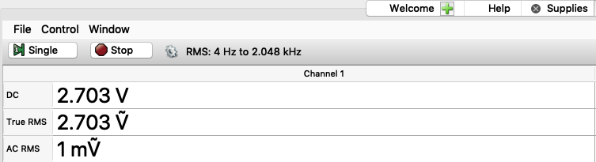

Figure 19: VRE = 5 – 2.703 = 2.297V for PNP Resistive DC biasing ▲

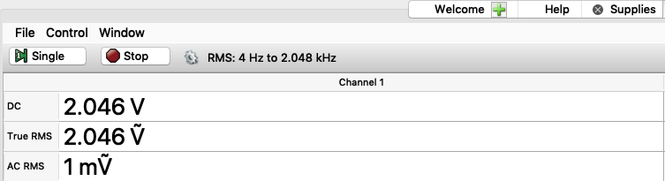

Figure 20: V2 = 5 – 2.046 = 2.954V for PNP Resistive DC biasing ▲

Ic = 1.525/1500 = 1.01mA

**(4)**

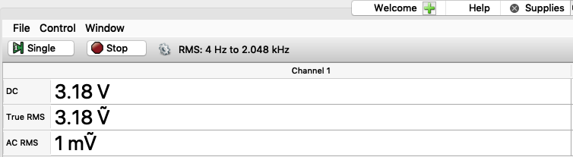

Figure 21: VC for NPN DC biasing circuit ▲

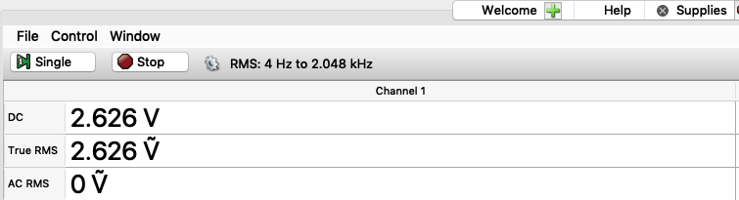

Figure 22: V2 for NPN DC biasing circuit ▲

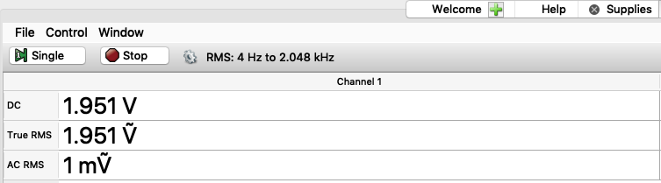

Figure 23: Vx for NPN DC biasing circuit ▲

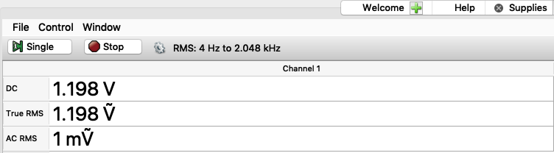

Figure 24: Vy for NPN DC biasing circuit ▲

Ic = (5 - 3.18) / 750 = 2.427mA

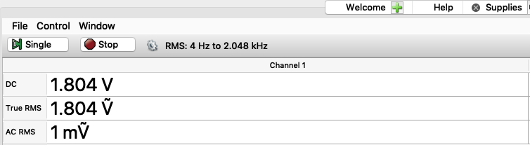

Figure 25: VC for PNP DC biasing circuit ▲

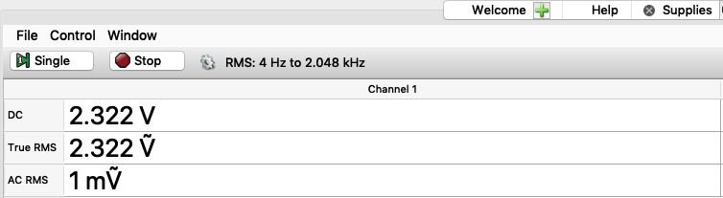

Figure 26: V2 = 5 – 2.322 = 2.678V for PNP DC biasing circuit ▲

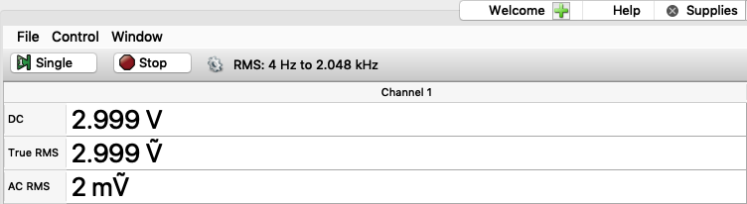

Figure 27: Vx = 5 – 2.999 = 2.001V for PNP DC biasing circuit ▲

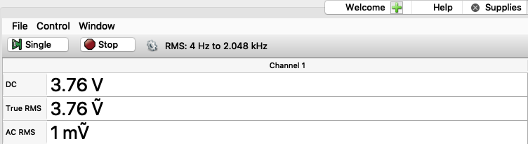

Figure 28: Vy = 5 – 3.76 = 1.24V for PNP DC biasing circuit ▲

Ic = 1.804 / 750 = 2.405mA

**Tables**

**NPN Resistive DC Biasing Circuit**

|  |  |  |  |
| --- | --- | --- | --- |
|  | Calculation | Simulation | Measurement |
| VC (V) | 3.5 | 3.49 | 3.424 |
| V2 (V) | 2.922 | 2.90 | 2.904 |
| VRE (V) | 2.222 | 2.24 | 2.255 |
| IC (mA) | 1 | 1.01 | 1.05 |

**PNP Resistive DC Biasing Circuit**

|  |  |  |  |
| --- | --- | --- | --- |
|  | Calculation | Simulation | Measurement |
| VC (V) | 1.5 | 1.49 | 1.525 |
| V2 (V) | 2.922 | 2.91 | 2.954 |
| VRE (V) | 2.222 | 2.2 | 2.297 |
| IC (mA) | 1 | 0.996 | 1.01 |

**NPN DC Biasing Circuit**

|  |  |  |  |
| --- | --- | --- | --- |
|  | Calculation | Simulation | Measurement |
| VC (V) | 3.5 | 3.51 | 3.18 |
| V2 (V) | 2.7 | 2.67 | 2.626 |
| Vx (V) | 2 | 1.98 | 1.951 |
| Vy (V) | 1.2 | 1.19 | 1.198 |
| IC (mA) | 2 | 1.99 | 2.427 |

**PNP DC Biasing Circuit**

|  |  |  |  |
| --- | --- | --- | --- |
|  | Calculation | Simulation | Measurement |
| VC (V) | 1.5 | 1.39 | 1.804 |
| V2 (V) | 2.7 | 2.68 | 2.678 |
| Vx (V) | 2 | 1.95 | 2.001 |
| Vy (V) | 1.2 | 1.19 | 1.24 |
| IC (mA) | 2 | 1.86 | 2.405 |

**Comment**

The calculation, simulation, and measurement values are all very close. However, measurement values are a bit off from the calculation and simulation values and this is because I used approximate resistor values but not exact resistor values.

For NPN and PNP characterization plot, both Ic vs. Vbe plots go up at around 0.6V which means that the transistor turns on at about 0.6V. And both Ic vs. Vce plots go up basically immediately that means Ic and Vce are going constantly.